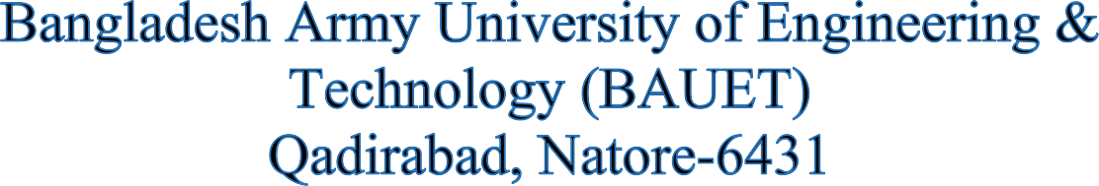



**Department of**

**Computer Science and Engineering (CSE)**

**Assignment**

**Course Code : CSE-2215**

**Course Title : Digital Electronics and Pulse Technique**

**Date of Submission : 12/11/2024**

**Date of Submission :** 18/07/2024

# **SUBMITTED TO:**

**Dr. Mirza A.F.M. Rashidul Hasan**

Professor & Adjunct Faculty,

Department of CSE, BAUET

**Must. Asma Yasmin**

Associate Professor,

Department of CSE, BAUET

# **SUBMITTED BY:**

**Name :** Md. Mueid Shahriar

**ID :** 0812220205101016

**Batch :** 16th

**Year :** 2nd

**Semester :** 2nd

**Session :** 2022-23